The Reynoldston Society (now defunct) met at the Hall during the 1980s and 1990s Its purpose was for members to learn more about local history but also to keep an unofficial “watching brief” on developments within the village.
“Members and friends spent an enjoyable and informative evening on March 15th when the Reynoldston Lecture was given by Dr. Anthony Ward. The title of the lecture was a “A Confusion of Cairns”, the subject being recent excavations on Cefn Bryn. At the AGM, held before the lecture, the following were elected: Chairman – Dr.J. Hayward; Vice-Chairman- Mr J.Morgan; Secretary – Mr.I.Campbell; Treasurer –Mr S.Emm; Committee – Messrs. Lucas, Evans, Fine, McGairl, Whitehead,Hughes.

The Reynoldston Youth Club was re-started at the Hall in the 1980s, after an absence of over thirty years. The Club ran for eight years, with Hugh Jones as Leader, with help from John Mahoney and Lyn Harkness. Membership was open to boys and girls of secondary school age. Table tennis, snooker, darts and other indoor games were available as was a video player. Trips were organised to the Pembrey Ski Centre, Oakwood Leisure Park, and the Grand Theatre. Cefn Bryn and Millwood were locations for elaborate hide and seek activities. The Youth Club members would perform a Christmas Pantomime for younger children. Early members included Andrew Rees, Rachel and Richard Bending, Andrew Griffiths, Catherine Mahoney, LouiseTurley, Michael and Michelle Bartley, Alison Campbell.....

Further Improvements to the Hall

The next few years saw major repairs and upgrading of the Main Hall, including a new central heating system, replacement windows and stage sound and lighting system. These improvements were paid for from local authority grants, the Arts Council of Wales Lottery Funding and various fund raising events. The Reynoldston Community Council continued with its financial support. Much work, as with all developments at the Hall were undertaken by volunteer labour. In 1995 the Hall was closed to enable the repairs to take place and the regular users at that time, The Women’s Institute, The Gardening Club and the Reynoldston Society met at the Methodist Chapel.

The WI obtained separate funding from the National Lotteries Charities Board in 1999 (£4,580) to refurbish the Minor Hall.

In 2001 the new kitchen and lavatory extension off the main hall was completed. A grant from the National Lottery, alongside local fund raising, helped to improve access to the Hall, particularly for wheel-chair users.

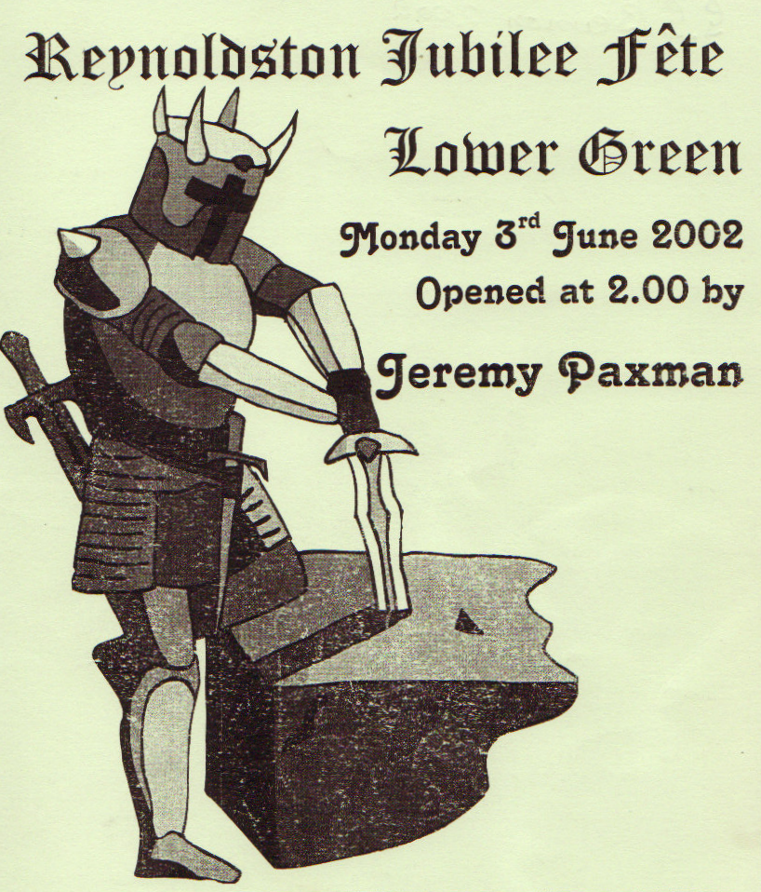
The Reynoldston Jubilee Fete of 3rd June 2002 was organised as a fund - raiser for the Village Hall. The fete was opened by Jeremy Paxman and over £1,000 was raised. Organisations using the Hall contributed in many ways on the day and the event was managed by a team led by Rob Vine (Howard Davies - Green Preparation, Angela Bending -Stalls, Steve Murray -Races, Paul Lloyd-Davies–Traffic and Safety, Carley Lloyd Davies –(WI Liaison), Paul Valerio - Raffles, Hugh Jones – Evening Dance, Dave Harvey - Publicity, Jenny Cooper – Fancy Dress, Adrian Hughes (Fire Service Demos) and Adrian Richards – Finance.
The fete concluded with a dance in the Hall, when live music was provided by Nightshift.

Fund raising took many forms at this time....Meryl Spencer, an employee of Barclays Bank, recently took part in the “Fear, Food and Fun” evening at Reynoldston Hall. The event was organised by Gower Players, who had agreed that all proceeds should be given to the Village Hall to improve facilities. Meryl played a key role in organising a most successful event, which raised over £1,000. Thanks to Meryl’s hard work, Barclays Bank has matched her contribution under its Employee Pound for Pound Scheme and the Village Hall has gained another £500! (2005)

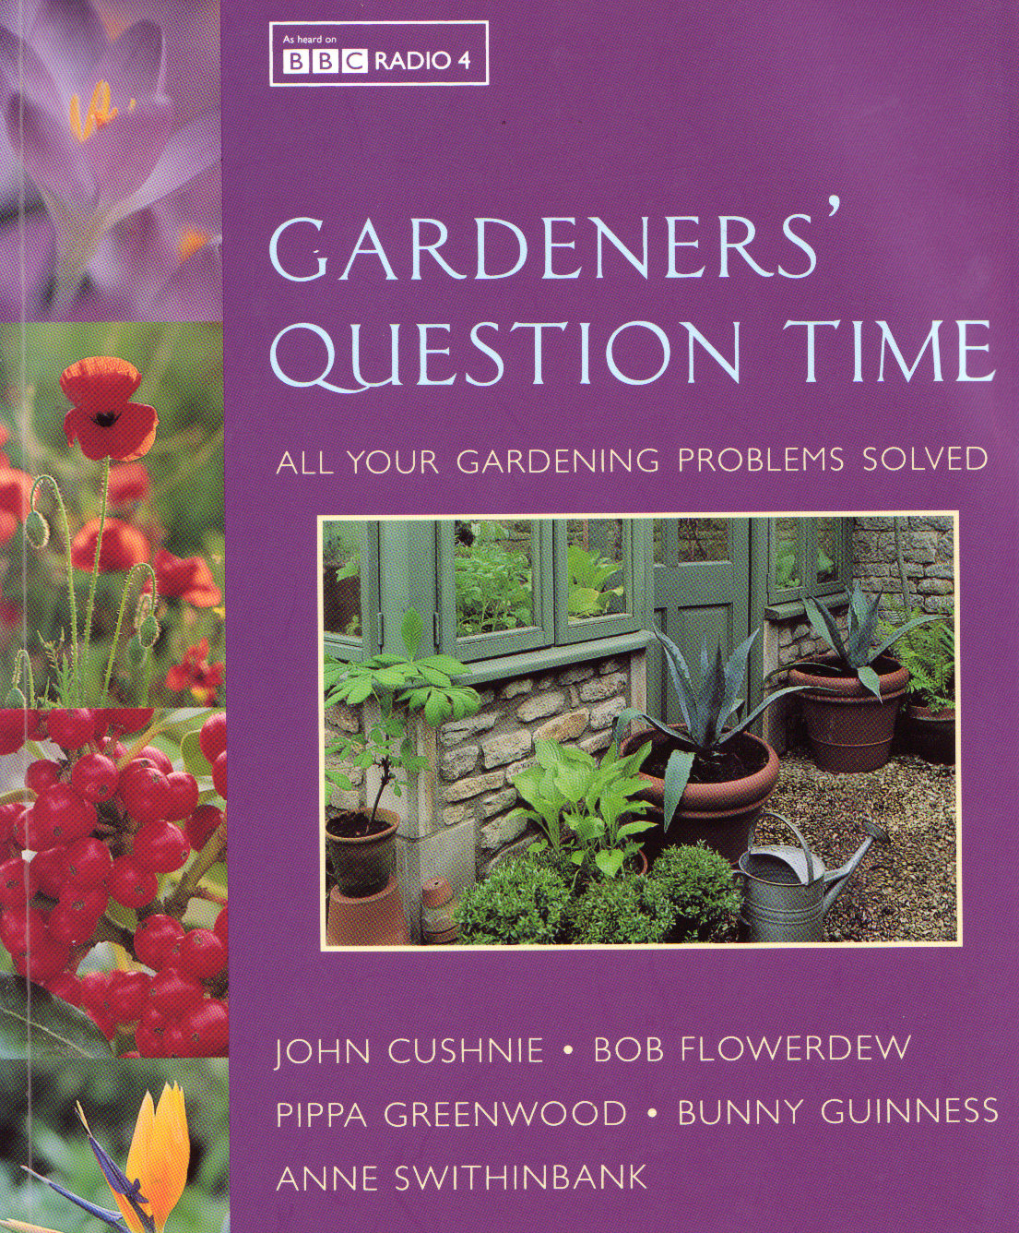
Alongside the regular organisations using the hall, there were the special events. An example was the visit of the BBC programme “Gardeners’ Question Time” in October 2006. The recording was made in the main hall in front of an audience of some 200. Carley – Lloyd Davies, on behalf of the WI, had invited this programme to Reynoldston each year for some eleven years. According to Godfrey Jefford, this was not the first visit to Reynoldston by the BBC. Any Questions, chaired by Wilfred Pickles was broadcast from the hall in the late 1940s. Pickles was a very well known broadcaster, famous for his long-running radio game show Have a Go.
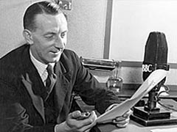

Increasing Use of The Hall 2007...................

The use of the Hall facilities increased substantially during this period. The Drama Group, Gower Players, were presenting two/three productions per year and the Social Committee of St.George’s Church were active in organising many fund raising events, including Harvest Suppers, Dinner Dances and Concerts. Regular users included the WI, Community Council, Badminton, Scouts, Cubs and Beavers, Keep Fit Classes, Fizzykids Play Scheme, Flower Arranging, Sunday School, Ballroom Dance Classes, South Wales Police (PACT), national and local elections, Gower Festival, Digital Photography Courses, Jumble Sales. The Hall, because of its size, has proved to be an excellent location for large-scale fund-raising events (Macmillan Cancer Support, Royal Welsh Show fundraising, Iona Appeal, Church fund raising, Prostate Research.....) as well as for private parties and wedding receptions.
Recent additions to the list of Hall users include, Zumba,Karate and Pilates classes. The Gower Film Club, which uses the short throw projector and the large screen at the Hall, has over one-hundred members.

The Hall, true to its community role, has been called in to help on sad occasions within the community. The funerals of Irene Davies, Howard Davies, Len O’Driscoll, Shirley Lee and Rose Prosser were attended by far more people than the Church could contain. Paul Valerio installed equipment so that the funeral service could be relayed into the Hall, where appropriate lighting and furnishing were provided.

Major Developments in 2008

This increased use of the Hall and its key role within the community encouraged the Trustees to embark on an ambitious re-development project in 2008. The cost was over £150,000 and included the re-development of the rear of the Hall, to include new toilets, storage areas, car parking areas retaining walls and the development of an upstairs meeting room. The old attic room was converted into a store for Gower Players which has been developed by Gillian Woodford into a highly effective costume and props facility. The kitchen was enlarged and brought up to modern standards as was the fire alarm, heating, lighting and electric systems. A wider apron to the stage, understage storage and a permanent bar area were built by volunteers. The Welsh Assembly Government awarded the Project £73,000, with further major grants coming from the Sports Council of Wales and the Gower Sustainability Fund. An appeal in the village raised £6,600.
Ian Campbell was the architect for this project, as he was for the other major developments at the Hall. Kevin Lloyd of Llanrhidian undertook the building work. The Trustees of the Reynoldston Village Hall Association managed the project: Hugh Jones (Chairman), Alan Bryant (Project Manager), Rob Vine (Treasurer), David Bending, Adrian Richards, Gerard Turley, Enid Jones, Dave Harvey, Sheila Williams, Wyn Cornelius and Paul Valerio. Further grants provided funding for the purchase of equipment including a short throw projector and large screen, tables and chairs for the new meeting room and table trolleys

