The Reynoldston Village Hall Association .... Regeneration 1991........and onwards

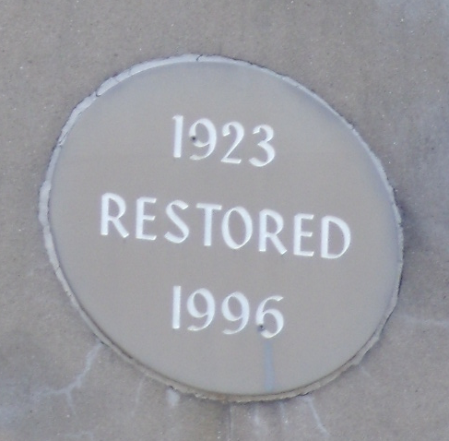
It was very obvious that major expenditure was required on the Church Hall. The Minor Hall was in a bad state of repair. All windows needed replacing, the heating and lighting systems were outdated and the facilities did not meet the demands of new Health and Safety Standards. Regular groups continued to meet, including a newly formed Youth Club, the Badminton Group, the Drama Group and of course, the WI.

There were by this time even suggestions that the Hall should be demolished and the land sold for housing!

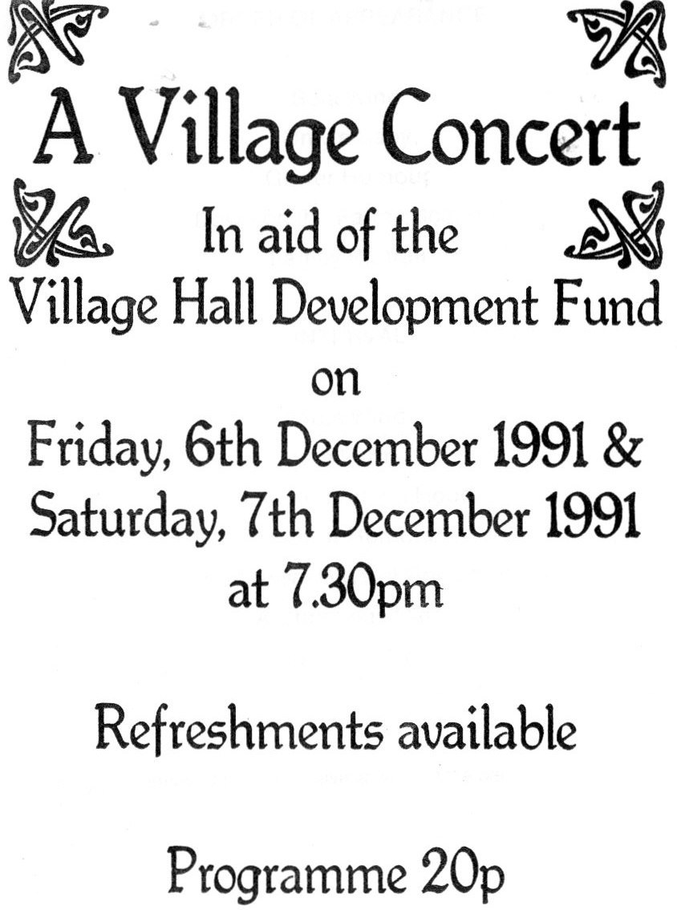
A Village Hall Development Fund was established in 1991 to raise funds to enable the Hall to be purchased from the Church in Wales and to undertake urgent repairs. A Village Concert in aid of this fund took place in December 1991. A remarkable number of local adults and children took part in this concert as the programme indicates:

