A First World War Grave in Gower.... A Double Tragedy
The grave of Lieutenant Colonel Richard Earle Benson lies in the graveyard of St. George’s Church Reynoldston. Benson, of the family living at Fairy Hill, was a professional soldier who had served in the Boer War. At the outbreak of war in 1914 he commanded the first battalion of the East Yorkshire Regiment. In September 1914 he was sent to France with his regiment where he led a full frontal and successful attack on the German lines at Aisne on the 20th September. Wounded, he was taken to a hospital in St. Nazaire where he died, age 51, on the 23rd September of tetanus and was buried in St. Nazaire. Benson’s brother, Judge William Denman Benson, travelled to France to bring his brother’s body back to Reynoldston for reburial. (this was allowed for senior officers and others who could afford the cost until the Government banned the repatriation of bodies). The private funeral took place on the 9th October when Benson was buried next to the grave of his father, General Henry Boxley Benson. Messages of sympathy came from the King and Queen and Lord Kitchener. The grave is recognised as a war grave by the War Graves Commission.
This was not to be the only tragedy to strike the Benson family. As Judge Benson returned from France with his brother’s body he learned of the death of his own son Captain John Penrice Benson at the age of 31. John Benson, who, like his uncle Richard Earle Benson, had served in the Boer War, had left the army in early 1914 to train for the priesthood. He was recalled to the East Surrey Regiment in August 1914 at the outbreak of war and left immediately for Belgium. Benson was seriously wounded in a skirmish before the Battle of Mons on 23rd August and taken prisoner. He died the following evening in the village school and was buried in the Hautrage Military Cemetery. Reports of the death were not released by the Germans for many weeks. John Benson left a widow, a young son and a daughter to be born in January 1915.
John Penrice Benson Richard Earl Benson
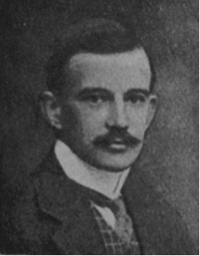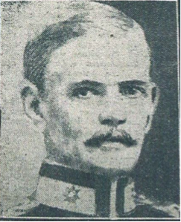

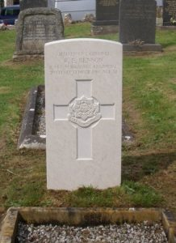
The War Graves Commission headstone, erected in August 2016, in St George’s Church Reynoldston

