Annual Report 2025 – 2026

Reynoldston Community Council

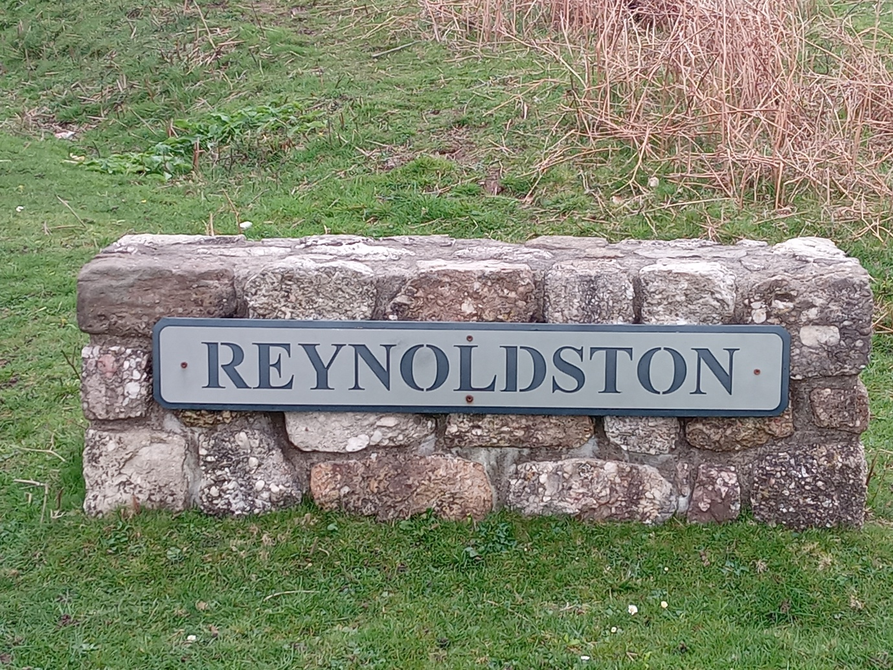

Introduction from Chair Michelle Clarke

Welcome to the Annual Report for Reynoldston Community Council 2025–2026.

It’s been another busy year, and this report gives us the chance to share what the Reynoldston Community Council (RCC) has been doing on your behalf, and how we plan to move forward into 2026–2027.

This year, we still have one vacancy which we hope to fill soon.

The other Councillors and the Clerk who also acts as the Responsible Financial officer remain unchanged and we note the hard work put in by all the Community Councillors and the Clerk here at Reynoldston Community Council.

The biggest change facing the Community Council is the oncoming Democracy and Boundary Commission Cymru’s review of Swansea’s community arrangements. We, along with Rhosilli, Port Eynon and Penrice Community Councils will be merging into one Community Council to be known as South Gower Community Council.

Village events this year have included:
- Love Reynoldston day where the Village members spent the morning clearing the stream in Robins Lane and also generally clearing litter around the Village using litter pickers supplied by the Community Council. It was noted how several families came out and enjoyed the event as a family. It was shame the rain did not hold off but this did not dampen the spirit of the event

- Digital Awareness – these were two events organised by Reynoldston Community Council and presented by Age Cymru. There was a good attendance at both events and we feel those attending learnt a lot about the safe use of their mobile telephones and tablets etc.

- We have planned a CPR/Defib training session in early April to support the Defibrillators we have around the Village.

Your Community Council

Reynoldston Community Council serves the community made up of the area surrounding Reynoldston, Little Reynoldston in part, Knelston in part and Fairyhill

Reynoldston Community Council consists of seven Councillors in total although currently we only have six appointed and employ a part-time Clerk whom also acts as the Responsible Financial Officer.

Whilst there have been no elections for new councillors in 2025-2026, we have had a number of vacancies throughout the year, one of which has been filled by co-option.

At the time of publication (May 2026) 1 vacant Councillor role remains

The Community Council sits six times a year, sitting every other month in January, March, may, July, September and November

The record of attendance shows:

Councillor | Position | Jan 26 | Mar 26 | May 25 | Jul 25 | Sept 25 | Nov 25
Cllr Clarke | Chair | √ | √ | √ | √ | √ | √
Cllr Twitchett | Vice Chair | √ | √ | √ | √ | Apol | Apol
Cllr Ashelby | Councillor | √ | √ | √ | Apol | √ | √
Cllr Cousins | Councillor | Apol | √ | √ | √ | √ | √
Cllr Thomas | Councillor | √ | Apol | √ | √ | √ | √
Cllr Spacie | Councillor | √ | √ | √ | Apol | Apol | √
Paul Sizer | Clerk & RFO | √ | √ | √ | √ | √ | √

Apol = Apologies

Apologies were accepted by the Community Council

Training

No other formal training was undertaken by the council in 2025-2026, however Councillors are able to access the full suite of online training available through One Voice Wales

Finance Summary 2025-2026

Receipts received:
Income for 2025 - 2026 |  | Notes
Precept | £8,000 | 1
Interest | £94
VAT refund | £570
Shared Clerk's cost with another CC | £75
Total | £8,739

Payments made:
Payments for 2025 - 2026 |  | Notes
Clerks Salary & NI contribution | £3,534 | 2
Room Hire | £142
Grants | £5,902 | 3
Insurance | £623
Local Works/Repairs | £5,442 | 4
Bank charges | £4
Councillor Expenses/Allowances | £780
SLCC and OVW Memberships | £237
Motor Mower expenses | £111
Audit Wales fees | £775 | 5
Christmas Tree & Lights | £250
Clerks expenses | £240
Website | £100 | 6
Emails expenses | £50
Total | £18,190

Summary Income, expenditure and reserve position
Balance as at 1st April 2025 | £15,041
Income for the year | £8,739
Expenditure for the year | £18,190
Balance as at 31st March 2026 | £5,990

Fixed Asset Register
The fixed asset register remains unchanged for this year and shows as:

Notes to the accounts

Precept (1)
Despite an expenditure greater than income for the year, the Community Council is still in a secure position having also reduced the precept asked of our residents of Reynoldston from £12,500 to £8,000.

Clerks Salary (2)
A national pay rise for Clerks was introduced by the National Association of Local Councils in October 2025 and backdated to April 2025. The Clerk’s hours and pay grade remained unchanged throughout the year. The Clerk’s Contract of Employment allows a band increase per year but the Clerk has forgone this increase only accepting the basic pay rise. The Clerk is employed for an average 4 hours per week.

Grants (3)
Over the year we are delighted to report grants have been offered to various organisations including:
- Reynoldston Village Hall
- St Georges Church in Reynoldston for the Graveyard upkeep
- Age Cymru
- Gower Players
- Reynoldston Badminton Club
- Reynoldston WI
- Reynoldston Village Newsletter

This year we have tried to award grants to smaller organisations who would usually not request support. We are delighted to have supported three of these plus a fourth is receiving a grant in 2026-2027.

Local Works/repairs (4)
Local Works this year have included:
- Cleaning and repainting and fixing a new gate to the old brick bus shelter - we have arranged for it to be power jetted clean, painted and a new gate fitted to hopefully stop the sheep visiting the bus shelter.
- Repairing the bunding to the upper green – this is to assist with stopping motor vehicles parking on the upper green. Stones have also been moved back into their original positions
- Re-stoning the parking area on the upper green. This area assists with parking for the King Arthur Hotel and visitors to Cefn Bryn and King Arthur’s stone and stops indiscriminate parking around the village.
- Work on clearing the culvert by the Post Office. Clearing the culvert by the Post Office and forming a line of large stones to help stop the smaller stones going down the culvert and into the drain system. This hopefully will also alleviate the flooding in that area we often see in times of heavy rain.

Audit Wales Fees (5)
The audit Wales fees showing in the expenses included charges for two separate years fees as no changes were received in last year’s expenses.

Website (6)
During the year, there was an issue with the Reynoldston.com website where access was lost due to not being able to make contact with the hosting company as they held an out-of-date email contact address for the Community Council and were not in a position to alter it or talk to the Council.

The Clerk managed to contact an old friend of his who wrote a new website for the Community Council at no charge and we are delighted this is now up and running again and holds all the information regarding the Community Council.

Internal Auditor
We are eternally thankful to Aimee Davies of Reynoldston who has acted as the Internal Auditor for the Community Council for several years.

Each year Aimee audits the accounts of Reynoldston Community Council and writes a report to Audit Wales on her findings. These reports are available to see through the Clerk on request.

External Audits
With the internal audit now complete, the Annual Return will be sent to Welsh Audit for inspection for 2025 - 2026.

Once we receive our final Audit report the accounts will be available for
public inspection and notices of their availability will be placed on the Village noticeboards and on the website.

Democracy & Boundary Commission Cymru’s review
A significant issue this year was the Democracy and Boundary Commission Cymru’s review of Community Council arrangements across the City and County of Swansea. The review was carried out by the Commission on behalf of the City and County of Swansea.

For South Gower, the recommendation is merging the four neighbouring Community Councils of Reynoldston, Penrice, Port Eynon and Rhossili into a single ‘super community council’, with just two Councillors for the Reynoldston area.

The Community Council have made comments about the proposals but they have not been accepted and the merger will go ahead in May 2027.

The Chair, Vice Chair and Clerk are currently attending meetings of the four Community Councils to be prepared for the merger.

Reynoldston Newsletter
After each meeting, the Community Council put an article in the Village Newsletter keeping residents aware of the actions of the Community Council and also include adverts of forthcoming events

Members of the public are welcome to attend the Reynoldston Community council meetings but attendance is very low.

Facebook
The Community Council have commenced a Facebook page posting events and links to the activities of the Community Council to keep our community aware of forthcoming events and Community Council activities.

Looking forward to 2026-2027
As we look ahead to the coming year, Reynoldston Community Council remains committed to strengthening our community and preparing for the changes that may lie ahead with the forthcoming merger.

This Annual Report was approved by the Reynoldston Community Council on 12th May 2026.

